Ravishankar Bhooplapur’s Biography.
Ravishankar “Ravi” Bhooplapur, a tireless Philanthropist & World Traveler. He initially served in the financial industry as an Insurance agent, manager and funded a successful insurance brokerage company Vision Financial Services in 1997. In 2009, he decided to expand into Education and start a Medical University in Aruba. Today, the institution is known as Xavier University School of Medicine. Xavier’s mission is to fill the shortage of physicians in North America. “Ravi” currently serves as the President of Xavier University School of Medicine, Aruba and is responsible for Pre Medical programs in Jordan, Palestine, Ghana, India, and in Turkey. Ravishankar Bhooplapur studied at JSS college Dharwad, India and migrated to New York in
1992.
2009-2010 Ravi served as a Rotary International Governor in New York.
Ravi has been instrumental with numerous worldwide humanitarian grants and medical missions. He has also secured millions of dollars in grants for all of his charitable initiatives.
Furthermore, he served as Treasurer for the Center for India Studies at Stony Brook University.
He helped many disaster relief efforts including Hurricane victims of Katrina, Tsunami at India,
Indonesia, and Sri Lanka.
Founder & Chairman of “Gift of Life India”, which has been instrumental in saving 6000 children in India by providing heart surgeries to children suffering from congenital heart disease.
In 2002, he also started “Naturophathy Center in Ghataprabha- India“with a capacity of a 100 bed hospital.
Ravi has received numerous awards & accolades
In 2012 he was awarded the prestigious “Ellis Island Medal of Honor”, which celebrates
medalists ‘professional contributions to the United States of America and their immigrant
heritage.
Rotary Foundation Highest Service above self
Meritorious Service Award.
Distinguish Service Award.
Proclamation from United State Congress Hon Gary Ackerman in 2009.
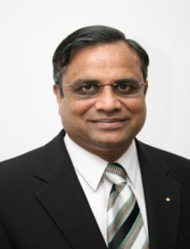
• Ravi is appointed to serve on Investment committee for Rotary Foundation for a period of 6
years, which manages $ 1.2 billion dollar investment for Rotary Foundation.
• He is the 4th Indian origin to enter of Hall of Fame in Rotary International in 2005.
• He is also the Hall of Fame at AXA insurance in 2004.
• Ravi is on the board of Trustee of Old Westbury University in Long Island, NY.

