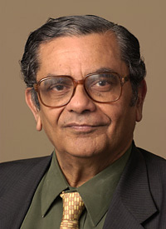
Dr. Jagdish N Bhagwati, University Professor Columbia University
Co-Chair, NIACC Economics Academic Advisory Board

Dr. Jagdish Bhagwati received the Ph.D. in Economics from the Massachusetts Institute of Technology in 1961 for a thesis titled "Essays in International Economics", supervised by Charles P. Kindleberger.
Dr. Bhagwati was an economics professor at the Massachusetts Institute of Technology. Bhagwati currently serves on the Academic Advisory Board of Human Rights Watch (Asia) and on the board of scholars of the Centre for Civil Society. He is a Senior Fellow of the Council on Foreign Relations. Dr. Bhagwati has previously served as an external advisor to the Director General of the World Trade Organization in 2001, as a special policy advisor on globalization to the United Nations in 2000, and as an economics policy advisor to the Director-General of the General Agreement on Tariffs and Trade, from 1991 to 1993.
In May, 2004, Dr.Bhagwati was one of the experts who took part in the Copenhagen Consensus project. In 2006, Bhagwati was a member of the Panel of Eminent Persons who reviewed the work of the United Nations Conference on Trade and Development (UNCTAD). In early 2010, Dr. Bhagwati joined the advisory board of the Institute for Migrant Rights, Cianjur – Indonesia.
At present, he is professor of economics and law at Columbia University.
• Mahalanobis Memorial Medal of the Indian Econometric Society (1974)
• Fellow of the American Academy of Arts and Sciences (1982)[11]
• Seidman Distinguished Award in International Political Economy (1998)
• Padma Vibhushan Award (2000)
• Lifetime Achievement Award of the Indian Chamber of Commerce (2004)
• Order of the Rising Sun, Gold and Silver Star (2006)

