Mamatha Shekar, Ph.D.
408.499.4696 ▪ Saratoga, CA

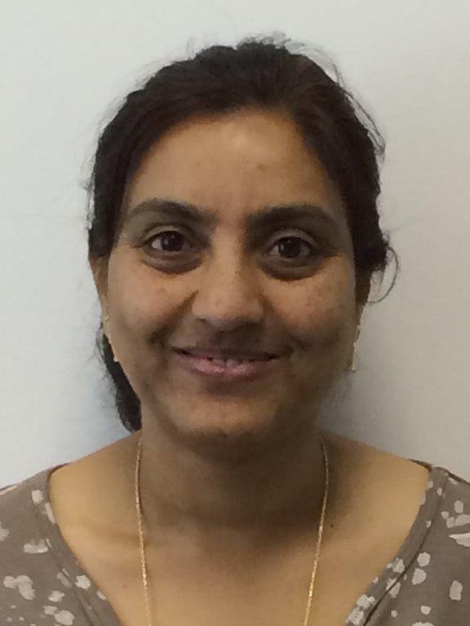

Mamatha Shekar is Director of Biomedical Informatics at Illumina, USA and Adjunct Professor of Human Disease Genetics at Centre for Human Genetics in Bangalore, India. She has over 30 years of industry experience specializing in genetics spanning from assay development to leading the development of innovative informatic software products for precision medicine. With doctorate degree in biotechnology, she topped her class in undergraduate and graduate studies winning national merit scholarships and awards. To her credit, she has over 20 publications in peer reviewed journals, chapters in few books and patents. As a leader in the field of genomic medicine, she has contributed to the establishment of standards for creating oncology reports. Passionate of both genetics and big data technologies, she continues to help advance genomic applications by conceptualizing new discovery and analytical platforms.

