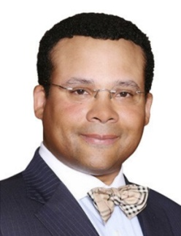
DAVID PRATT

David Pratt is a Partner at the lobbying firm, The Southern Group. David joined the Southern Group’s Atlanta office in 2009 after holding a myriad ofroles in the political arena. Nearly two decades as a lobbyist, David has developed expertise in numerous policy areas, including business development, appropriations, health care, medical marijuana, energy, local government, public safety, public-private partnerships, and economic development.
David enjoys very strong relationships in Government across the ideological spectrum.In 2001, David became a contract lobbyist; and, has since then,successfully lobbied on behalf of Fortune 500 companies and small businesses alike. Prior to this work, David was hired as a lobbyist for the Georgia Society of Ophthalmology (GSO) and was named the GSO’s deputy director by the end of his first year. David began his political career in 1998as legislative aide to then Representative Ben Harbin, Chairman Emeritus of House Appropriations.
David served in the enlisted ranks of the United States Army from 1990 to 1993. After receiving a commission in 1996, David served as an Army Reserve Officer until honorably discharged in May of 2003. David graduated Valedictorian at Marion Military Institute (1994-96), after which he transferred to the University of Georgia majoring inpolitical science (1996-98). David has also earned his Certificate of Negotiation from Harvard University Kennedy School of Government (2015).
Civically, David is an active member, and passedboard member of the University of Georgia Rugby Alumni Association; and, he served asVice Chairman of the Sons of Marion Military Institute Foundation Board. David is also a member of severalother organizations, including the High Museum of Art in Atlanta, Metropolitan Museum of Art in New York, and the Atlanta Symphony Orchestra.
David is from Saint Marys, Georgia, and now resides with his wife and their two sons in Atlanta.

