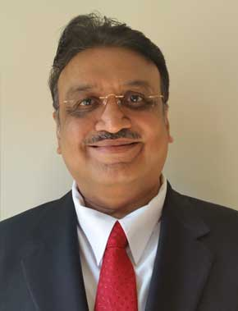
Mr. Narendra Shah
President & Regional Director [USIACC SE Atlanta Region]

Mr. Narendra Shah is a visionary leader. He is the CIO - Chief Information Officer / EVP - Executive Vice President [Global] of LD Capital LLC and LD Capital Bridge to USA. LD Capital provides business loans in the USA and mega business loans in India. It also facilitates EB-5 investor green cards working with business investors and the U.S. Citizenship and Immigration Services / Department of Homeland Security’s approved Regional Centers and their approved Projects. He has over 35 years of IT, Finance, Analytical, Consulting, Management, Marketing, Educator and Business Development experience. He also has significant Project Management, Business Analyst, Quality Assurance and Project Coordination experience in IT, Finance, Revenue Management and Management Information Systems. Mr. Narendra Shah holds an MBA from Texas Tech University and a BBA from West Texas A&M University. He also holds a MCA - Master of Computer Applications from Maharashtra Tilak University, Pune, India and B.Com. - Bachelor of Commerce from Jai Hind College, Mumbai, India. He speaks 5 languages fluently – English, Hindi, Gujarati, Marathi and Kutchi.

He has worked with Delta Air Lines, Inc., Texas Tech University and Radio Shack, managed more than 25 turnkey IT and Finance projects and managed more than 50 IT and Finance staff. He has inventively taught IT with Internet based, display sharing system based, “learn with fun and fun with learning” method to more than 1 Million Students in the USA and India from Pre-School [18 month old students - toddlers onwards] to Post-Graduates, including English Medium and Non-English Medium [Vernacular] Students; a global pioneer in multiple ways. He has also authored in-house IT books for IBM Logo, MS Windows, MS Word, MS Excel, MS PowerPoint, Internet, BASIC, Etc., for School and College Students in more than 15 of his own FCCe IT Centers in India. He had partnered with Intel and Microsoft Corporations, facilitating “Teach to the Future” teacher IT training programs.

