Mr. Vasudev Patel
Regional Director [USIACC SE Atlanta Region]

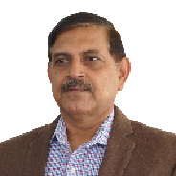
Mr. Vasudev Patel a medical professional from India is passionate to work for community in India as well as in USA. He is also an entrepreneur and involved in diversified business in USA. His more than three decade of residency in USA he has worked in the field of clinical trial, clinical laboratories and Forensic Toxicology field as a Scientist. He is deeply associated with various nonprofit organizations in USA and an Overseas Indian political organization.
He was always aggressive and activist student leader while in high school and college. He received his medical degree in 1980. Then he joined with his father's Medical practice in Mehsana, Gujarat. Besides his private medical practice he was playing active role in Tuberculosis and Polio society of India in local chapter, to help and educate about the benefits to villagers and encourage them to be vaccinated to save their lives and stop further spreading those killer diseases. Actively involved and served in different positions in Indian politics as well in community organizations. He played a lead role in Junior Chamber of commerce and teaches the young students for future leadership role in the society, with the attachment to Red Cross society and St. Jo Ambulance International of India. Trained hundreds of volunteers and drivers for emergence first aid treatment and CPR.

