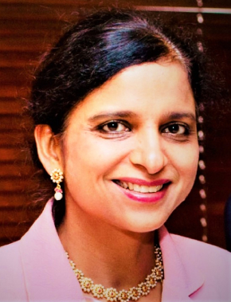
Gurdeep Kaur Chawla, PhD.
Member, Executive Board
Dr. Gurdeep Kaur Chawla is a successful entrepreneur based in the heart of Silicon Valley, USA, with a track record of over 28 years, working in the field of public diplomacy and the corporate world, involved with articulating messages of the Heads of State in different languages. She has had the unique honor of working with 7 Prime Ministers of India, 3 Presidents of the US, and 2 Prime Ministers of Canada. She is widely traveled across the globe, working at international forums such as the UN, WHO, World Bank, G20 Summit, G-7 Summit, the Conference on Climate Change, the ASEAN, and the US-India Strategic and Commercial Dialogue.

Gurdeep is currently the CEO of Indian Languages Services LLC located in Silicon Valley, California. She also serves as the Principal at India US Business Partners (IUSBP), an international strategic advisory firm, and Advisor at Digitalonus, besides serving as Senior Fellow for an independent Think Tank, Imagindia

With her vast knowledge in cross-border trade, understanding of cultural differences and other bureaucratic challenges, Dr. Chawla advises companies small and large wanting to expand business from US to other parts of the world. She had the rare honor to serve as an advisor and bridge for visiting delegations from India and Canada, helping prepare them for their US presentations at a critical time of the US-India and US-Canada relationship. Dr.
Chawla helped facilitate communication and helped them arrive at a common understanding to establish agreements. She has been the keynote speaker at Berkeley-India Conference on US-India cultural Ties, US-India Future Connectivity Series organized by USIBC, and has given numerous presentations at Indian Institute of Public Administration, New Delhi Institute of Management etc.

Gurdeep was awarded Commendations by the City of San Jose and the City of Saratoga for helping facilitate communication between leaders of world’s largest democracies. She is also the Global Brand Ambassador of Come Clean India initiative.

E-Mail: gurdeepchawla@iaicc.world
Mobile: +1 408 476 3564

