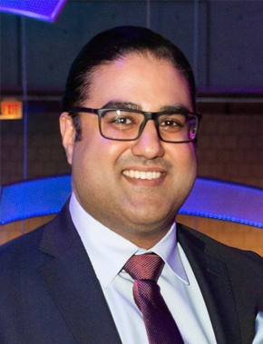
Sanjeev P. Yadav is the founder of The Inno Hub, which is an innovation growth platform and venture development firm with offices in Boston, London, and Delhi. We drive innovation and scale-up with companiesboth small and large by making business sense out of your future and providing the fuel needed for next levelinternational growth. He is also the Co-Founder and Managing Partner of Banyan Tree Capital, a boutiquemulti-family office investment advisory firm. He is also an active early stage and growth stage investor inprivate companies.
Prior to his current roles, he was a Vice Consul with the British Consulate-General Boston and UK Trade andInvestment (UKTI). At UKTI, Sanjeev guided companies to explore international expansion and trade opportunities in and with the UK as well as assisting UK companies as they sought to enter and expand into theUS marketplace. In addition, Sanjeev hosted visiting Ministerial and multiple sectoral start-up delegations.
Previously, Sanjeev worked at Kensington Capital Holdings, LLC, a Single-Family Investment Office where hewas an analyst involved in the monitoring and due diligence of an Alternatives-based investment portfolio. Hehas also worked with investment consulting firm NEPC LLC, on the private markets due diligence team.
Sanjeev is an active mentor and board advisor to startups and companies in the US, UK, and India. He also isthe founder of the MassIndia Partnership, a non-profit trade industry association that seeks to build trade andinvestment links between the New England states and India. He is a former Charter Member of The IndusEntrepreneurs (TiE) and an active advisor to a number of states in India in matters of development and FDI aswell an advisor to the Indian Prime Minister’s Office’ innovation efforts. Sanjeev led a delegation fromMassachusetts to attend the Global Entrepreneurship Summit 2017 in Hyderabad, India as part of the USdelegation coordinated with USAid and the US State Department.
Sanjeev was appointed by Governor of Massachusetts Charlie Baker as a Trustee of the Board of Trustees ofBunker Hill Community College where he also serves on the finance/audit committee. He is an Emeriti Trusteeof the University Of Vermont Board Of Trustees and an active member of the Museum Council of the Boston
Museum of Fine Arts. He also serves on the Board of Directors for the Boston Chapter of Pratham USA, thelargest education NGO in India. He received his B. Sc. from the University of Vermont and was a member ofthe Mortar Board National Honor Society and the National Society of Collegiate Scholars.
Sanjeev splits his time between Boston, Massachusetts, USA and London, United Kingdom.

